Lab 2 :

Question 1 :

Write a program to find GCD using consecutive integer checking method and analyze its time efficiency.

```
#include <stdio.h>
#include <stdlib.h>

int gcd(int m, int n, int *opr)
{
for (int i = (m > n ? n : m); i > 0; i--)
{
(*opr)++;
if (m % i == 0 && n % i == 0)
{
return i;
}
}
}

int main()
{
int m, n;
scanf("%d %d", &m, &n);
int opr = 0;
int result = gcd(m, n, &opr);
printf("The gcd is %d and the operation count is -> %d\n", result, opr);
}
```

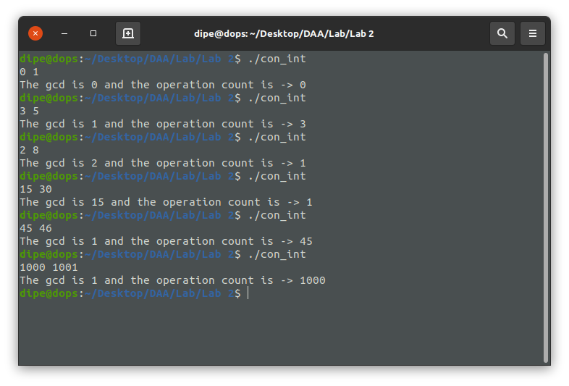
The basic operation for this algorithm is comparison.

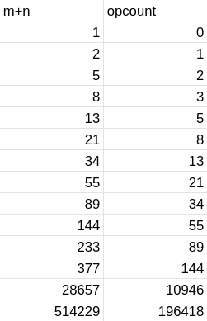

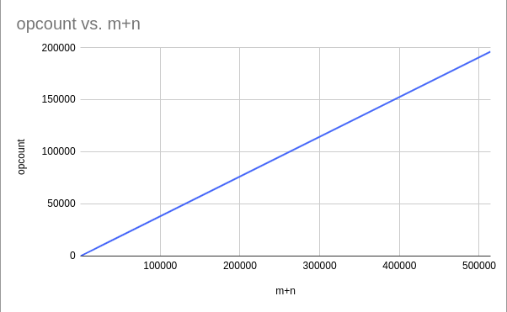

As we can observe from the graph plot that the time complexity for the following algorithm is
O(min(m,n)) which belongs to O(n+m).

Question 2 :

Write a program to find GCD using middle school method and analyze its time efficiency.

```

#include <stdio.h>
#include <stdlib.h>

void sieve(int m, int arr[])
{
for (int i = 2; i < m + 1; i++)
{
arr[i] = i;
}
int j;
for (int i = 2; i < m + 1; i++)
{
if (arr[i] != 0)
{
j = i * i;
while (j <= m)
{
arr[j] = 0;
j = j + i;
}
}
}
}

int pf(int n, int arr[], int *op)
{
int narr[n + 1];
sieve(n, narr);
int i = 2;
int cnt = 0;
while (i <= n)
{
(*op)++;
if (narr[i] != 0)
{
if (n % narr[i] == 0)
{
arr[cnt] = narr[i];
n = n / narr[i];
cnt++;
}
else
{
i++;
}
}
else
{
i++;
}
}
return cnt;
}

int gcd(int m, int n, int *opr)
{
if (m == 0 || n == 0)
{
*opr = 1;
return m == 0 ? n : m;
}
int marr[m], narr[n], op1 = 0, op2 = 0;
int a = pf(m, marr, &op1);
int b = pf(n, narr, &op2);
*opr = op1 + op2;
printf("Prime factors of %d -> \t", m);
for (int i = 0; i < a; i++)
{
printf("%d\t", marr[i]);
}
printf("\nPrime factors of %d -> \t", n);
for (int i = 0; i < b; i++)
{
printf("%d\t", narr[i]);
}
printf("\n");
int i = 0, j = 0;
int result = 1;
while (i < a && j < b)
{
if (marr[i] == narr[j])
{
result *= marr[i];
i++;
j++;
}
else if (marr[i] < narr[j])
{
i++;
}
else
{
j++;
}
}
return result;
}

int main()
{
int m, n;
scanf("%d %d", &m, &n);
int opr = 0;
int result = gcd(m, n, &opr);
printf("The gcd is %d and the operation count is -> %d\n", result, opr);
return 0;
}

```
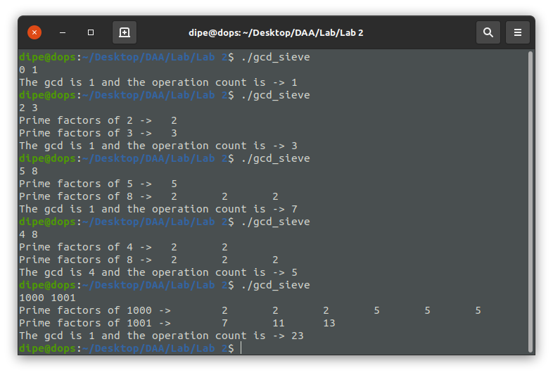

The basic operation is comparison.
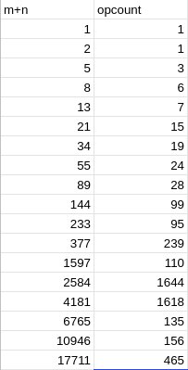

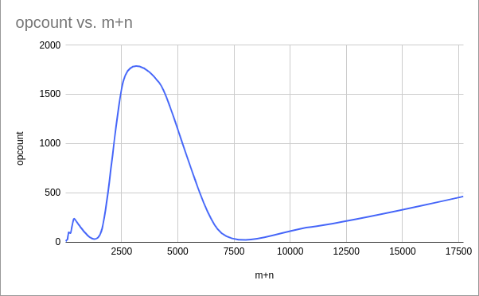

As we can observe from the graph plot that the time complexity for the following algorithm is O(n+m).

